Worksheet 1.1

Student Name: Ayush Yadav UID: 25IMC13004
Branch: MCA (AI & ML) Section/Group: MAM-1 (A)
Semester: II Date of Performance: 12/01/26
Subject Name: Advanced Internet Programming Subject Code: 25CAP-656

1. Aim/Overview of the practical:
Experiment-1:
To create a client–server communication application using HTML forms and a Java Servlet, where the client collects user data (First Name and Last Name) and submits it to the server using both GET and POST methods. The servlet retrieves the submitted data and displays it in the browser.

2. Coding:
<!index.html>
<!DOCTYPE html>
<html>
<head>
<title>Client Server Communication</title>
</head>
<body>
<h2>GET Method</h2>
<form action="UserServlet" method="get">
First Name: <input type="text" name="fname"><br><br>
Last Name: <input type="text" name="lname"><br><br>
<input type="submit" value="Submit using GET">
</form>
<hr>
<h2>POST Method</h2>
<form action="UserServlet" method="post">
First Name: <input type="text" name="fname"><br><br>
Last Name: <input type="text" name="lname"><br><br>
<input type="submit" value="Submit using POST">
</form>
</body>
</html>

#NewServlet.java
import java.io.IOException;
import java.io.PrintWriter;
import jakarta.servlet.ServletException;
import jakarta.servlet.annotation.WebServlet;
import jakarta.servlet.http.HttpServlet;
import jakarta.servlet.http.HttpServletRequest;
import jakarta.servlet.http.HttpServletResponse;

@WebServlet("/NewServlet")
public class NewServlet extends HttpServlet {

protected void service(HttpServletRequest request, HttpServletResponse response)
throws ServletException, IOException {

response.setContentType("text/html");
PrintWriter out = response.getWriter();

String method = request.getMethod(); // GET or POST
String fname = request.getParameter("fname");
String lname = request.getParameter("lname");

out.println("<html><body>");
out.println("<h2>Data received using " + method + " method</h2>");
out.println("First Name: " + fname + "<br>");
out.println("Last Name: " + lname);
out.println("</body></html>");
}
}

OUTPUT:-
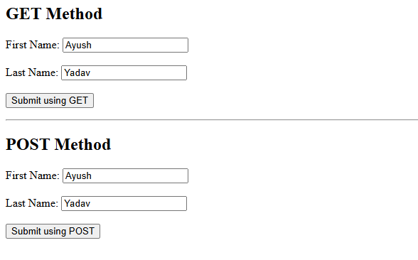
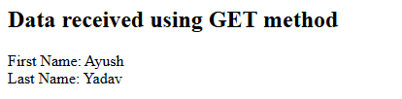

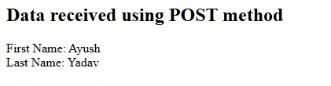

3. Learning outcomes (What I have learnt):
- Understand client–server architecture by implementing communication between an HTML client and a Java Servlet server.
- Learn how to create and design HTML forms with input fields and configure them to send data using GET and POST methods.
- Differentiate between GET and POST requests by observing how data is transmitted and handled on the server side.
- Gain hands-on experience in servlet programming, including handling HttpServletRequest and HttpServletResponse.
- Develop the ability to retrieve, process, and display user input dynamically using server-side Java technologies.

